T-Dyl's Gumbo

Serves 6-10 (6 hungry boys, 10 lady folk)

**Ingredients:**

Roux:

1 cup flour  
 1 cup vegetable oil  
Everything else:

1 yellow onion

1 bunch of celery

2 green bell peppers

4 cloves of garlic or enough for 1.25 tablespoons

1/2 pack of andouille sausage

1 pack of bone-in chicken thighs (enough meat per person)

Enough water to cover the meat in ya pot or chicken broth if you feel bougie

Alternatively, chicken bouillon to taste

Tony’s / Slap Ya Mama seasoning to taste

Paprika to taste

Cayenne to taste

Salt to taste

Pepper to taste

3 cups cooked rice

King’s Hawiian rolls “Optional”

**Process:**

1.) Prep:

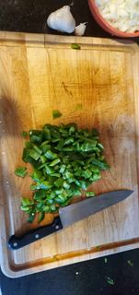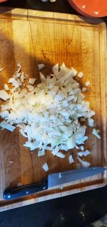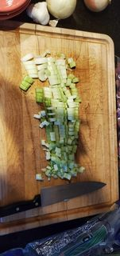



2.) Roux: The secret is (1:1 ratio fat : flour). Pour your flour in the pot. Pour the oil over the flour Mix together over a medium / low heat. Keep stirring until it is a dark chocolate color - do not stop stirring or it will burn and you’re done for! “If your roux don’t look like poo it’s not going to taste good.” It’ll take a while to start changing colors but once it starts it’ll move quickly!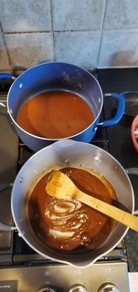

3.) Vegetables:

Put your onion, bell pepper, and celery in the pot. Cook for 40ish minutes. 15ish minutes in throw in the minced garlic. You don’t need to stir as often now but still regularly

4.) Meat:

While veggies are cooking down, put a little bit of oil in another pan on medium heat and pan sear the chicken thighs to caramelize the skin. Helps keep it all together while in the pot instead of falling apart. Flip it over and do the other side. Don’t cook all the way. Once veggies are cooked down / tender, throw the sausage and the chicken in the pot. 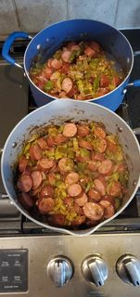

5.)Fill your pot with chicken/(water + chicken bouilion) enough to cover the meat. 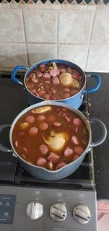

6.) Throw your seasonings in the pot to taste in order of importance/ amount: Cajun seasoning, salt, pepper, paprika, cayenne.

7.) Cover the pot. Let it do it’s thing for like 2-4 hours - however long it takes. Stir every 20-30 minutes and fill with more water and chicken bouillon as it evaporates.

8.) Take apart the chicken so the heathens don’t take a whole thigh.

9.) Serve over rice.